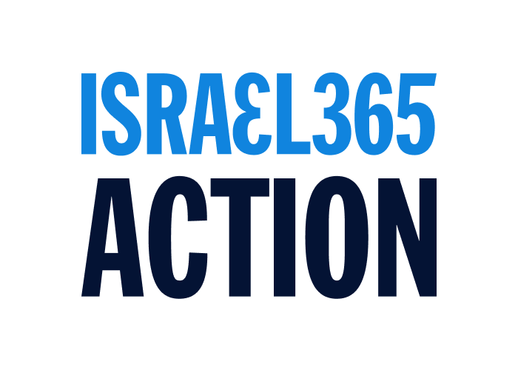
April 8, 2025 / 10 Nissan 5785
Dear Herbert,
This letter responds to your correspondence dated April 7, 2025 (the “Allegation Letter”) warning of the “scheme to manufacture votes and defraud” the election process. The tactics you outlined of suspicious email addresses coupled with prepaid credit cards are unfortunately the foreseeable outcome of impropriety we communicated to the AZM earlier in the campaign. We share in your distress and appreciate your call for suggested solutions.
With so much riding on this election, and now with several slates seemingly involved in deceptive voting practices under public scrutiny, the AZM should summon all resources to thoroughly investigate activities that, if corroborated, undermine the “generally accepted democratic principles” of the election as set forth in the WZO Constitution (Art. 19, sec. 1). This will require adopting and implementing robust formal review procedures surpassing those currently in place, to restore trust in the “parliament of the Jewish people.”
We, therefore, strongly recommend the following four items:
- Publication of Procedures: The AZM and WZO shall establish and publish rules of procedure to govern a comprehensive investigation and disclosure of all claims contained in the Allegation Letter. Such procedures must promote transparency and be designed to restore full trust in the AZM and our National Institutions.
- Due Process Guarantees: Any satisfactory resolution must include comprehensive assurances that principles of due process will be observed at all phases of adjudication. This will mean protections for all interested parties’ rights to discovery of evidence, to depose witnesses, and the orderly compilation and maintenance of records that meet accepted legal standards.
- Integrity and Security Standards: The AZM and WZO shall refresh and strengthen their procedures and protocols to investigate and guarantee election security, and each party must be required to adopt internal protocols to ensure the highest standards of integrity. We must confirm that the instances of alleged fraud that have been detected are not merely the tip of a much larger iceberg, and also must guarantee that future election proceedings are free of such nefarious activities.
- Procedural Schedule: The AZM shall publish and implement a procedural schedule that ensures full redress of the allegations, including comprehensive investigations, thorough discovery, proper hearings and final adjudication. As a result, like with previous procedural AZM deadlines, we suggest extending the election period to give adequate time to accommodate the highest standards of electoral integrity for this 2025 election.
Israel365 Action is still collecting information and reviewing its available options. Israel365 Action reserves all rights under any applicable laws, governing documents, or regulations regarding the 2025 Zionist Congress Elections.
The prophet Isaiah promised that one day the world will look to Jerusalem for guidance: “He shall judge between the Nations, and shall decide disputes for many peoples...For out of Zion shall go forth the law, and the word of Hashem from Jerusalem” (Isaiah 2:2-3). Israel365 Action strongly believes that the Nations already look to the Jewish People for wisdom, and we call upon the AZM and the WZO to demonstrate the meaning of righteous governance worthy of the Zionist Movement.
May our actions bring honor to our ancestors’ legacy and secure our children’s future by pursuing righteousness and justice so that we “may live and inherit the land that the Lord your God is giving you” (Deuteronomy 16:20).
Wishing you a Happy and Kosher Pesach. Next Year in Jerusalem, Judea & Samaria!
Rabbi Tuly Weisz
on behalf of the Israel365 Action Slate

